November 4, 2025

FLORANTE AUSTRIA FRANCISCO, PhD
Principal II
Sta. Maria Integrated High School
Santa Maria, Laguna

Dear Sir:
Greetings of peace and prosperity!
The undersigned from Grade 12 - STEM students of Sta. Maria Integrated High School are currently conducting a study entitled “QUIEAZY: FUN, EASY TO USE, LIVE INTERNETLESS QUIZ APPLICATION”.
With this, the researchers are asking your permission to conduct the aforementioned.
Rest assured that the information once gathered will be used solely for this study and will be treated with full confidentiality.

We are looking forward to seeing you favored our request. Thank you!
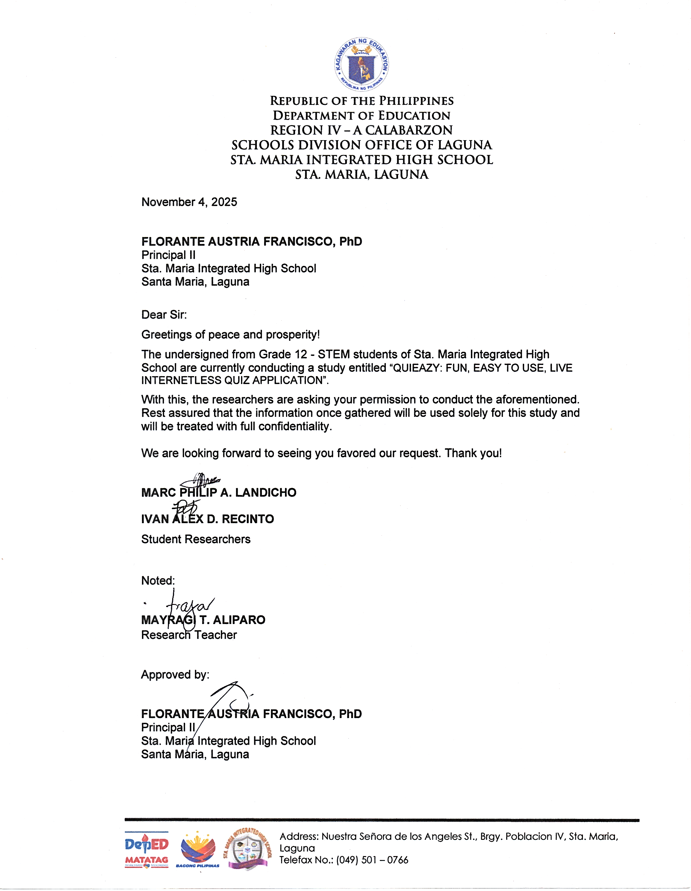
MARC PHILIP A. LANDICHO
IVAN ALEX D. RECINTO
Student Researchers

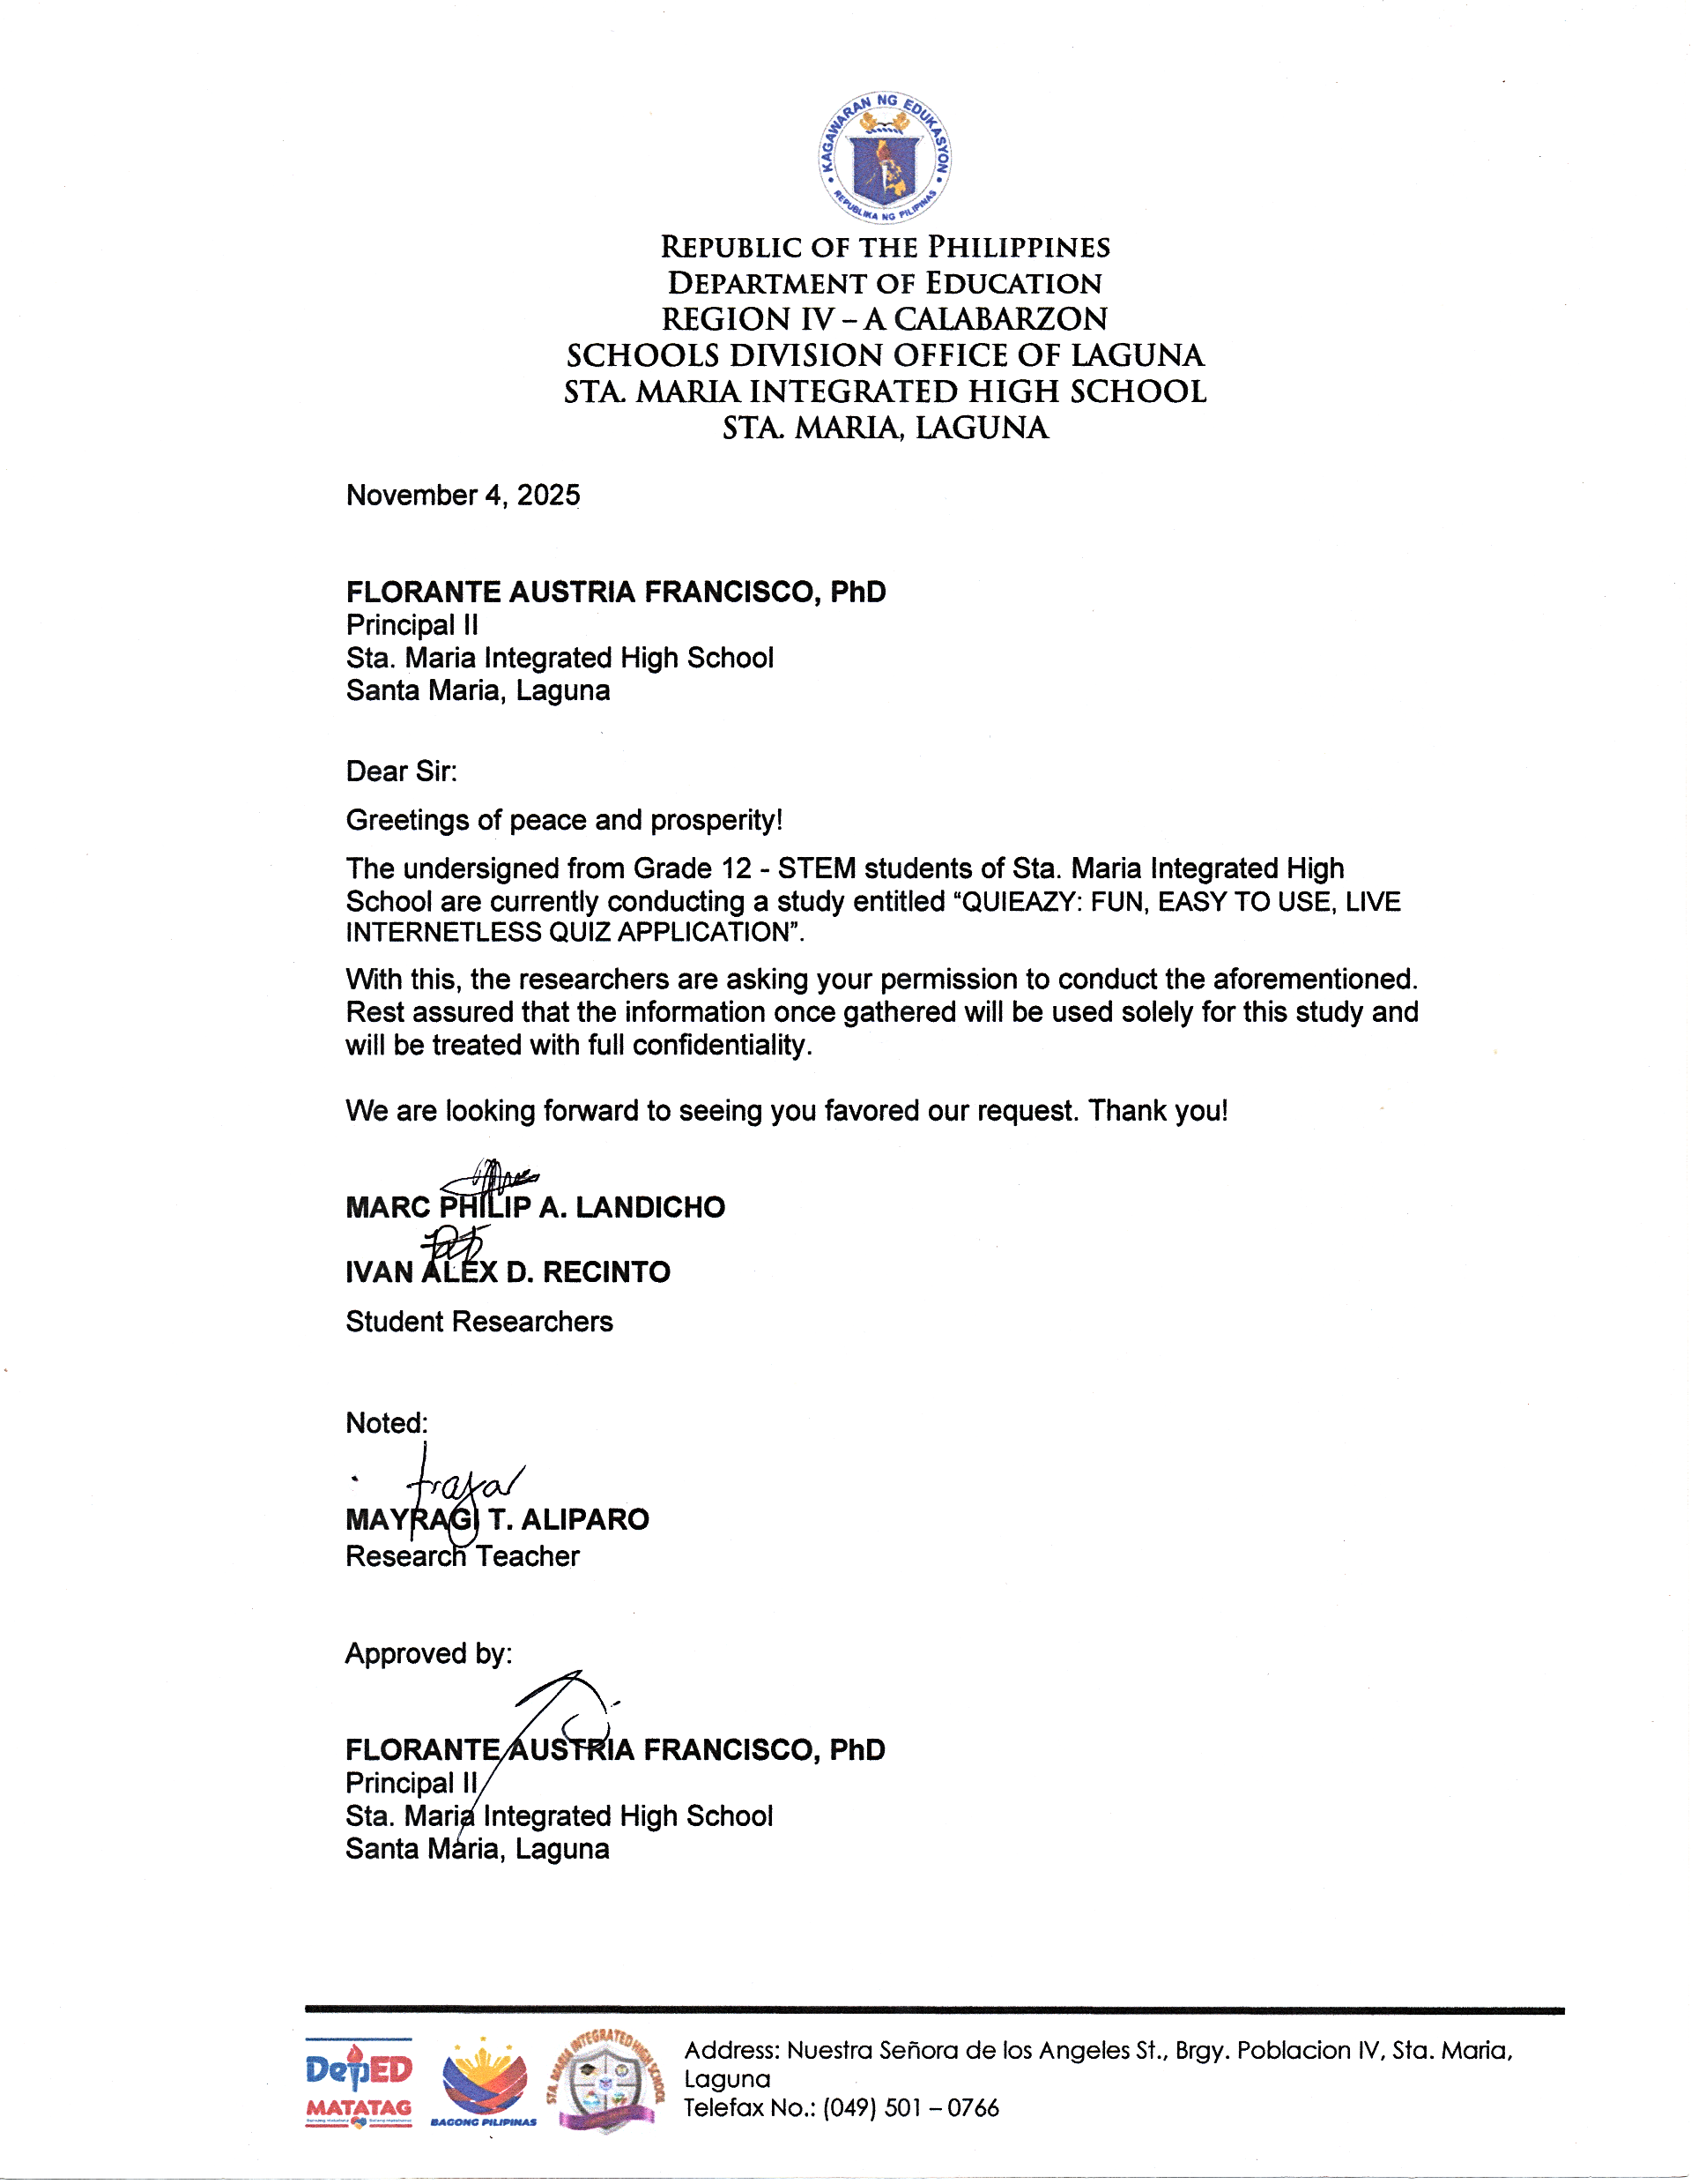
`Noted:

MAYRAGI T. ALIPARO
Research Teacher

Approved by:

FLORANTE AUSTRIA FRANCISCO, PhD
Principal II
Sta. Maria Integrated High School
Santa Maria, Laguna

November 4, 2025
FLORANTE A. FRANCISCO, PhD
Principal II
Sta. Maria Integrated High School
Santa Maria, Laguna

NATALIO C. AGUADO
SHS Coordinator
Sta. Maria Integrated High School
Santa Maria, Laguna

Dear Sir:
Greetings of peace and prosperity!
The undersigned are Grade 12 Science, Technology, Engineering, and Mathematics (STEM) researchers from Sta. Maria Integrated High School, are currently working on a research study entitled “QUIEAZY: FUN, EASY TO USE, LIVE INTERNETLESS QUIZ APPLICATION”.
With this, the researchers are formally requesting your good office the permission to conduct a survey to all Senior High School learners in your institution.
Rest assured that whatever information the respondents provide will be treated with utmost confidentially and professionalism according to the research ethics. Your favorable response to this request will be highly appreciated.

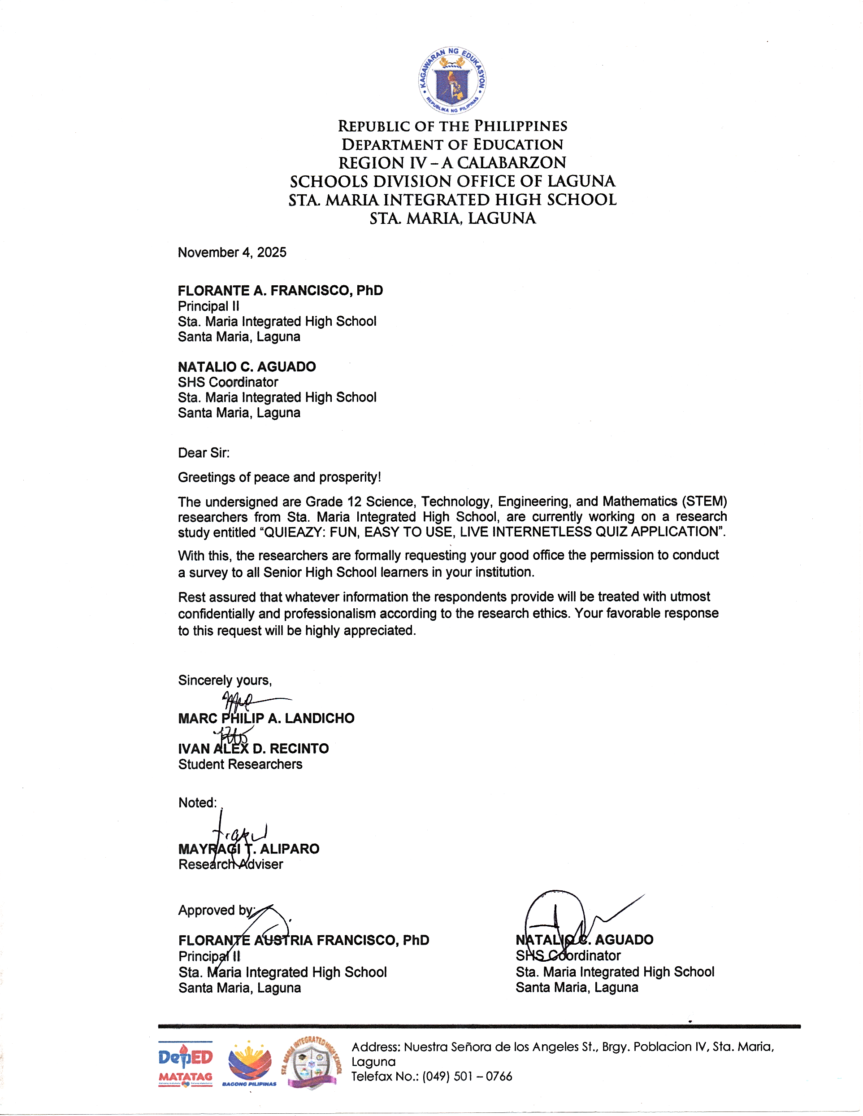
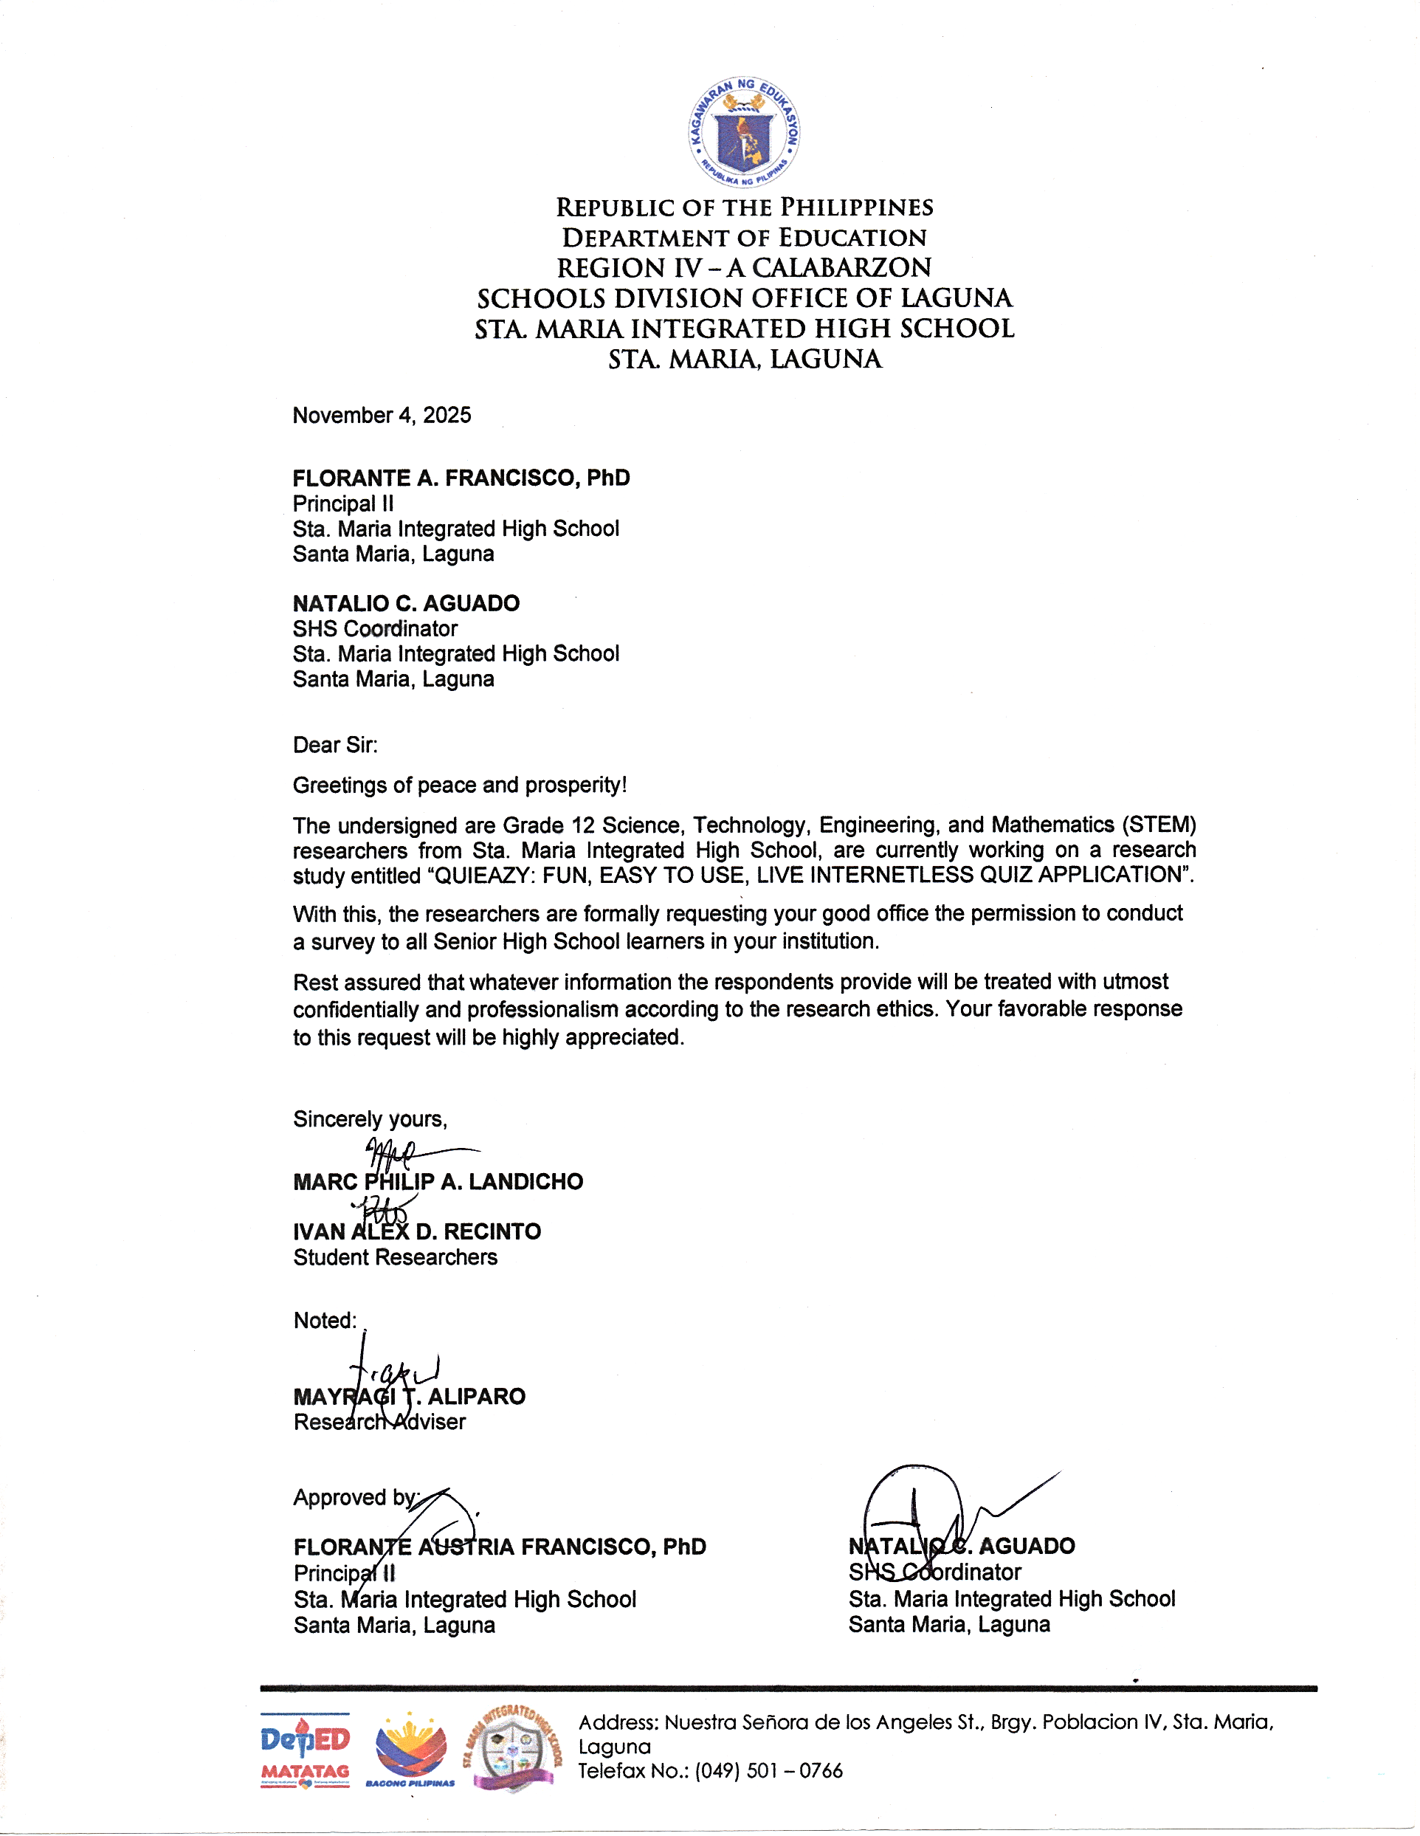
Sincerely yours,
MARC PHILIP A. LANDICHO Noted:
IVAN ALEX D. RECINTO MAYRAGI T. ALIPARO

Student Researchers

Approved by:

FLORANTE AUSTRIA FRANCISCO, PhD NATALIO C. AGUADO
Principal II SHS Coordinator
Sta. Maria Integrated High School Sta. Maria Integrated High School
Santa Maria, Laguna Santa Maria, Laguna

CERTIFICATE OF CONTENT VALIDATION

This is to certify that the researchers’ questionnaire for the study “QUIEAZY: FUN, EASY TO USE, LIVE INTERNETLESS QUIZ APPLICATION” submitted by Marc Philip A. Landicho, Ivan Alex D. Recinto, Rianer Justin O. Namuco, and Zcherheine A. Torrefranca was validated by professionals. The professionals can assure that the questionnaire underwent careful evaluation and proved to be highly efficient for the research study.

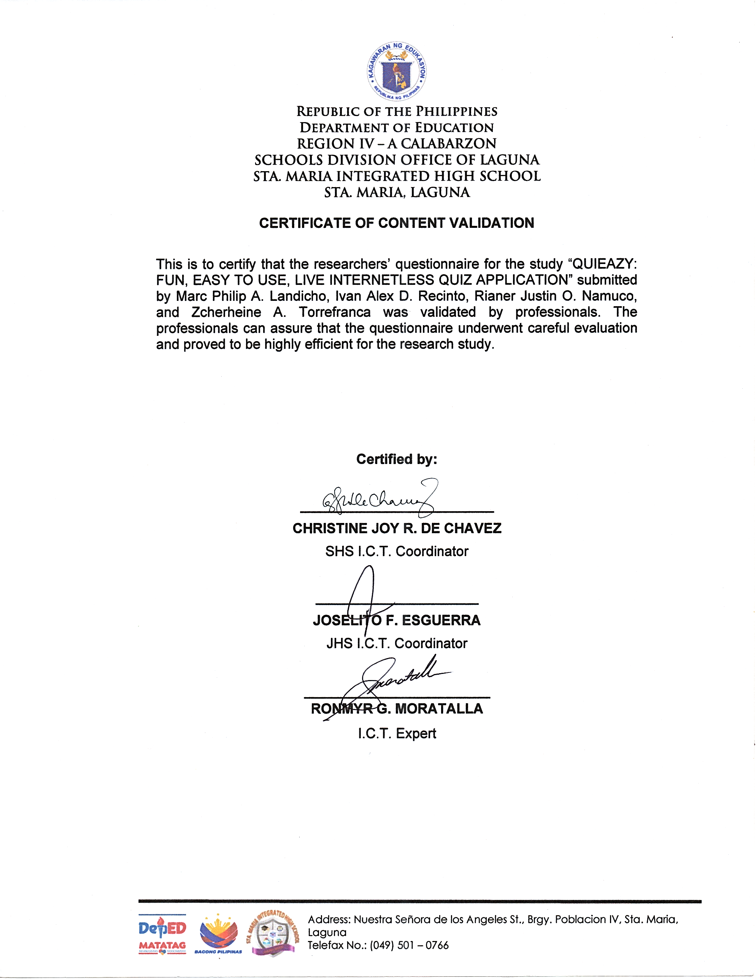
Certified by:

_________________________
CHRISTINE JOY R. DE CHAVEZ
SHS I.C.T. Coordinator

_____________________
JOSELITO F. ESGUERRA
JHS I.C.T. Coordinator

________________________
RONMYR G. MORATALLA
I.C.T. Expert

CERTIFICATE OF CONTENT VALIDATION

This is to certify that the researchers’ questionnaire for the study “QUIEAZY: FUN, EASY TO USE, LIVE INTERNETLESS QUIZ APPLICATION” submitted by Marc Philip A. Landicho, Ivan Alex D. Recinto, Rianer Justin O. Namuco, and Zcherheine A. Torrefranca was validated by professionals. The professionals can assure that the questionnaire underwent careful evaluation and proved to be highly efficient for the research study.
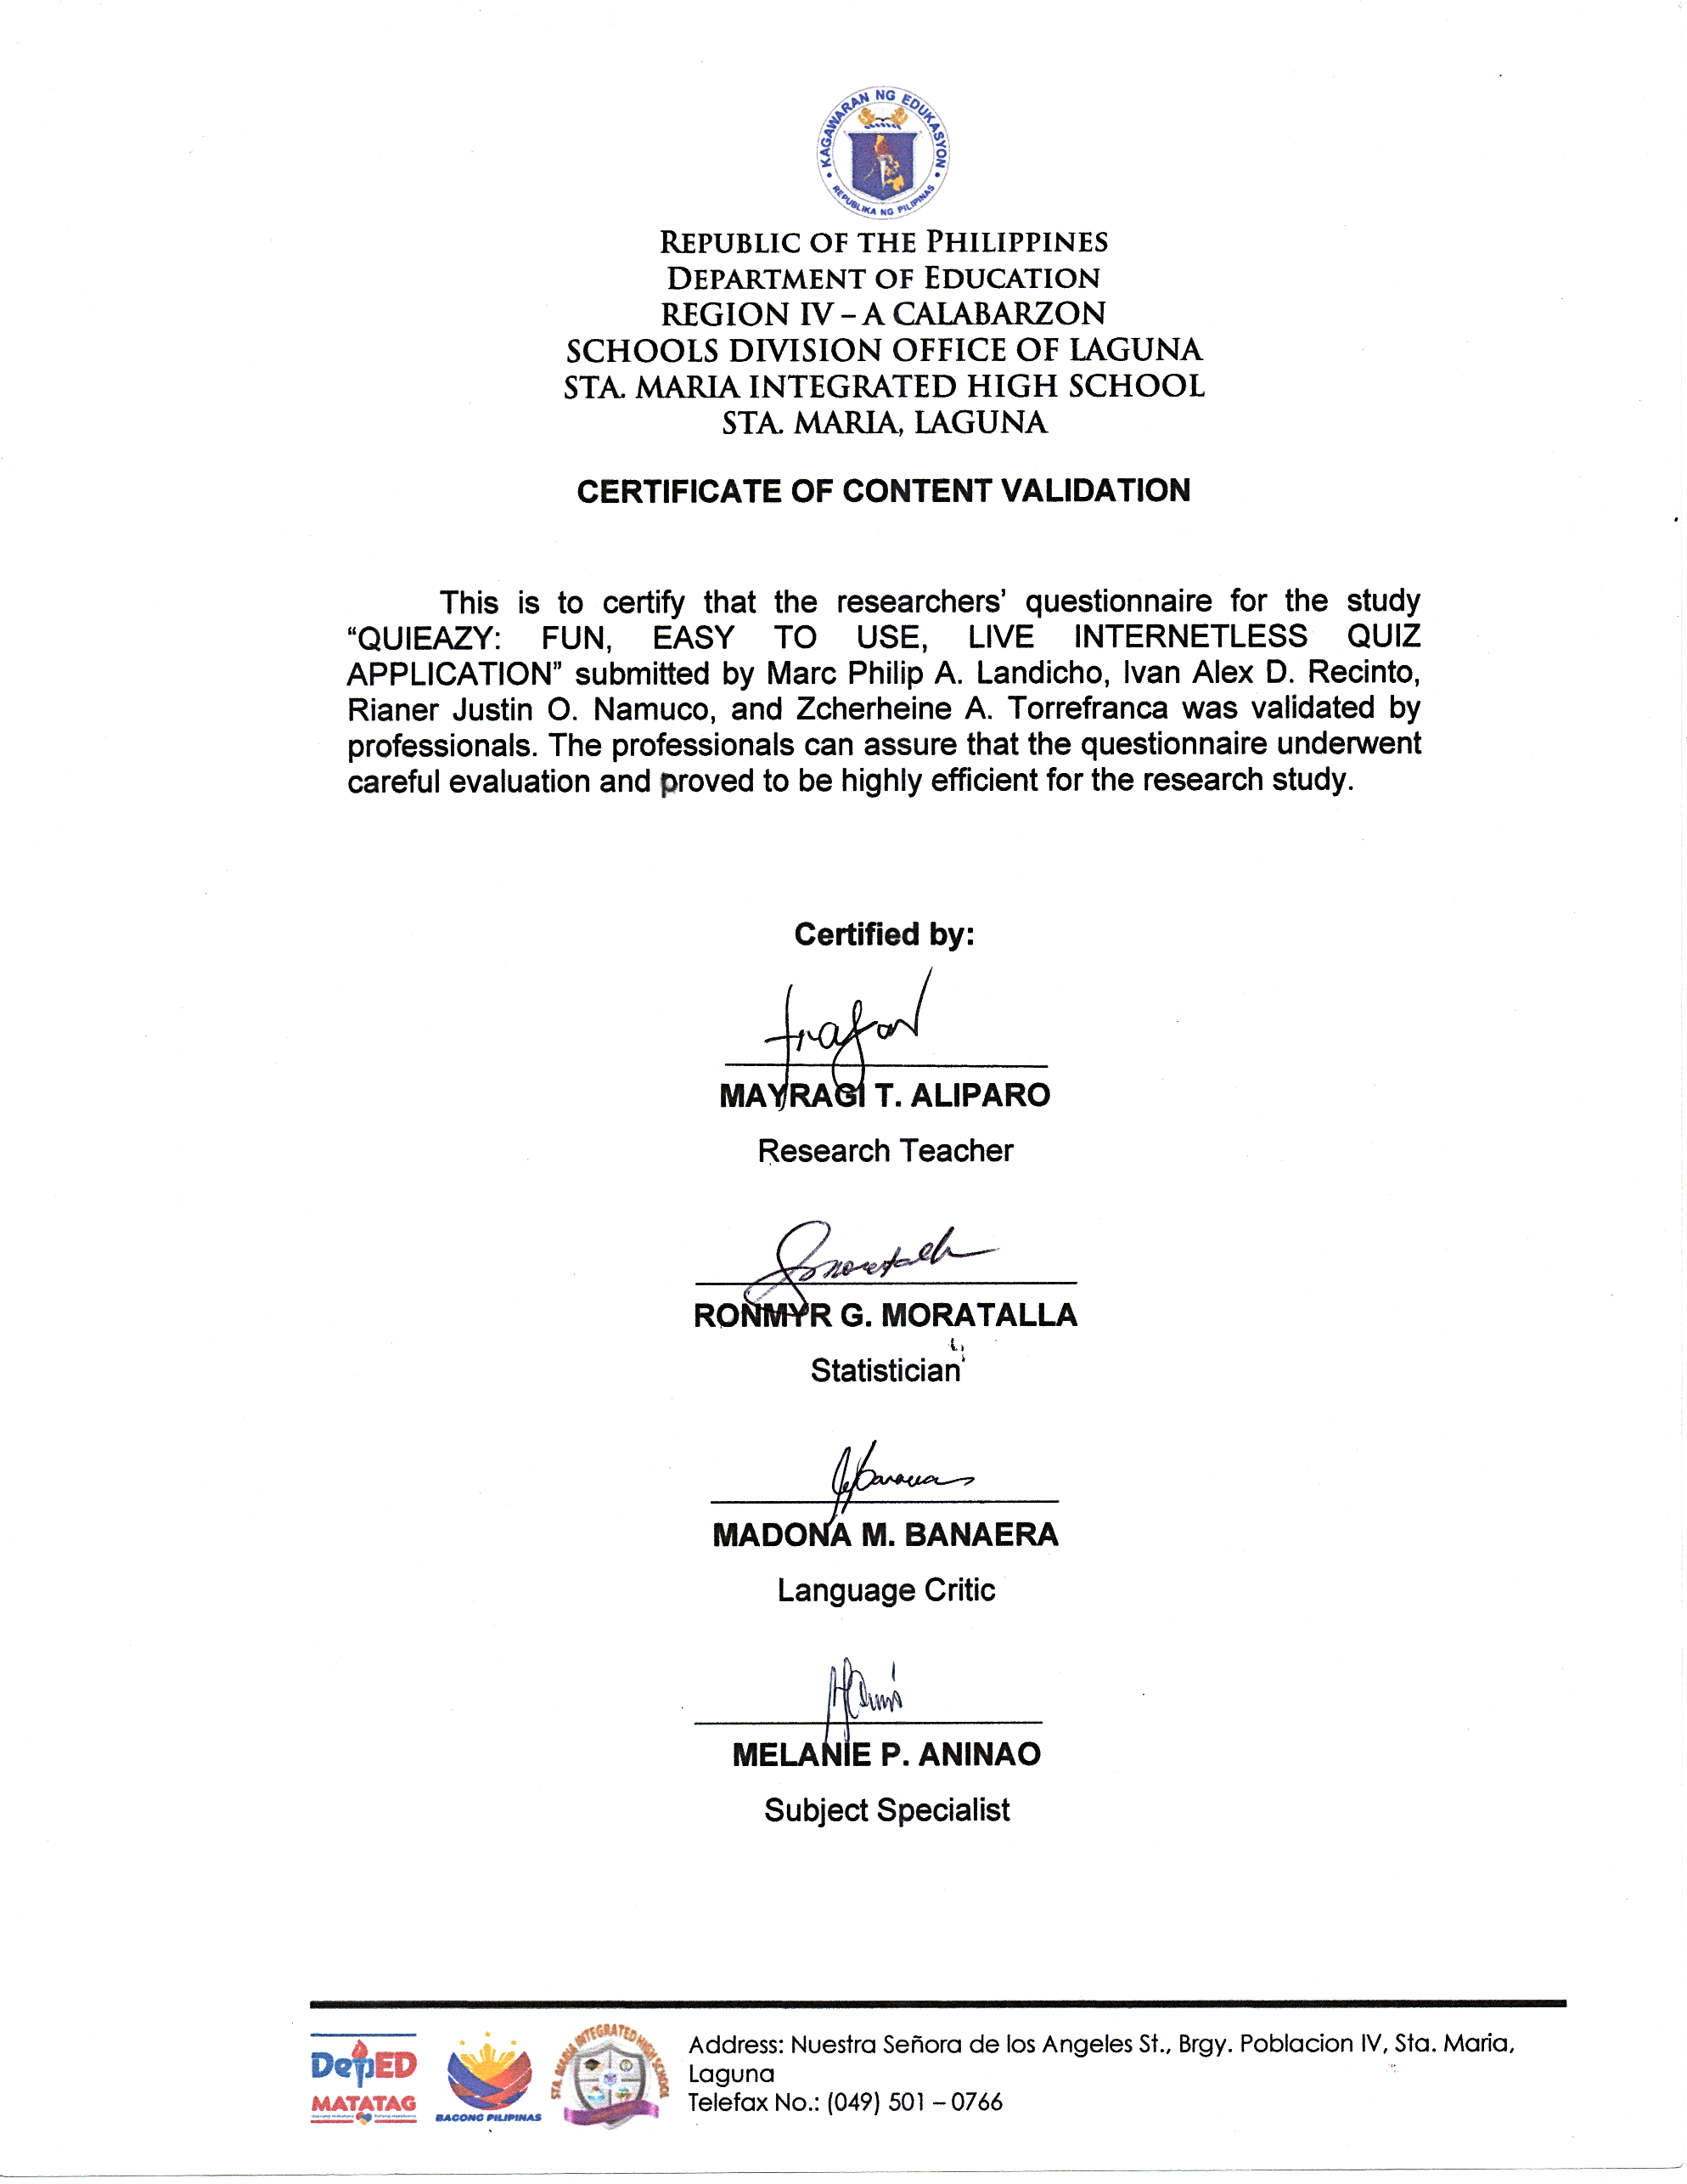
Certified by:

MAYRAGI T. ALIPARO
Research Teacher

RONMYR G. MORATALLA
Statistician

MADONA M. BANAERA
Language Critic

MELANIE P. ANINAO
Subject Specialist

VALIDATON of the Research Output
(Science, Technology, Engineering, and Mathematics)

Research Title: QUIEAZY: Fun, Easy to Use, Live Internetless Quiz Application
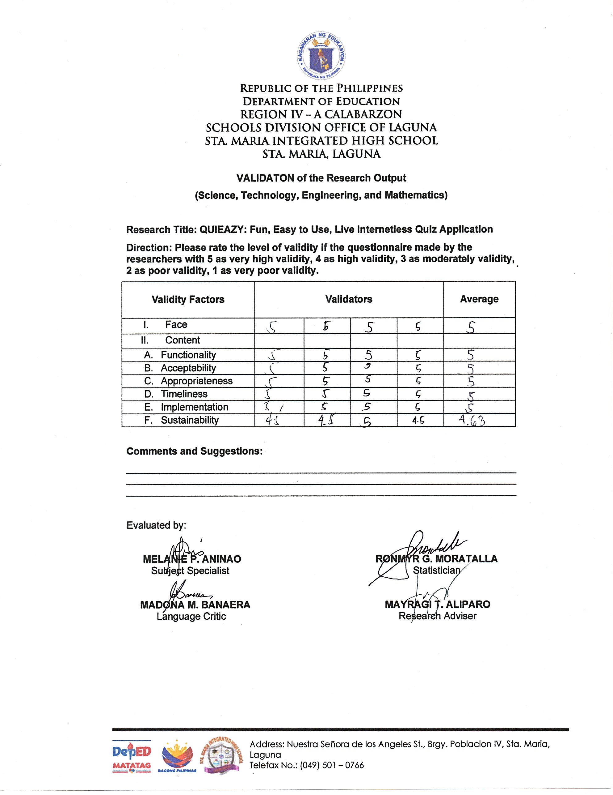
Direction: Please rate the level of validity if the questionnaire made by the researchers with 5 as very high validity, 4 as high validity, 3 as moderately validity, 2 as poor validity, 1 as very poor validity.
Validity Factors | Validators |  |  |  | Average
I. Face
II. Content
- Functionality
- Acceptability
- Appropriateness
- Timeliness
- Implementation
- Sustainability

Comments and Suggestions:
___________________________________________________________________________________________________________________________________________________________________________________________________________________________

Evaluated by:

MELANIE P. ANINAO RONMYR G. MORATALLA
Subject Specialist Statistician

MADONA M. BANAERA MAYRAGI T. ALIPARO
Language Critic Research Adviser

Dear Respondent,
Greetings of Peace and Prosperity!
We, Marc Philip A. Landicho, Ivan Alex D. Recinto, Rianer Justin O. Namuco, and Zcherheine A. Torrefranca students from Science, Technology, Engineering, and Mathematics (STEM) researchers from Sta. Maria Integrated High School are currently working research study entitled “QUIEAZY: FUN, EASY TO USE, LIVE INTERNETLESS QUIZ APPLICATION.”
In connection with the aforementioned study, we respectfully seek your honest response to the following questions to acquire precise data for our study. The data you will provide will be treated with utmost confidentially.
We sincerely appreciate your cooperation with this matter.
Respectfully Yours,
The Researchers

VALIDATON of the Research Tool
(Science, Technology, Engineering, and Mathematics)

Research Title: QUIEAZY: Fun, Easy to Use, Live Internetless Quiz Application
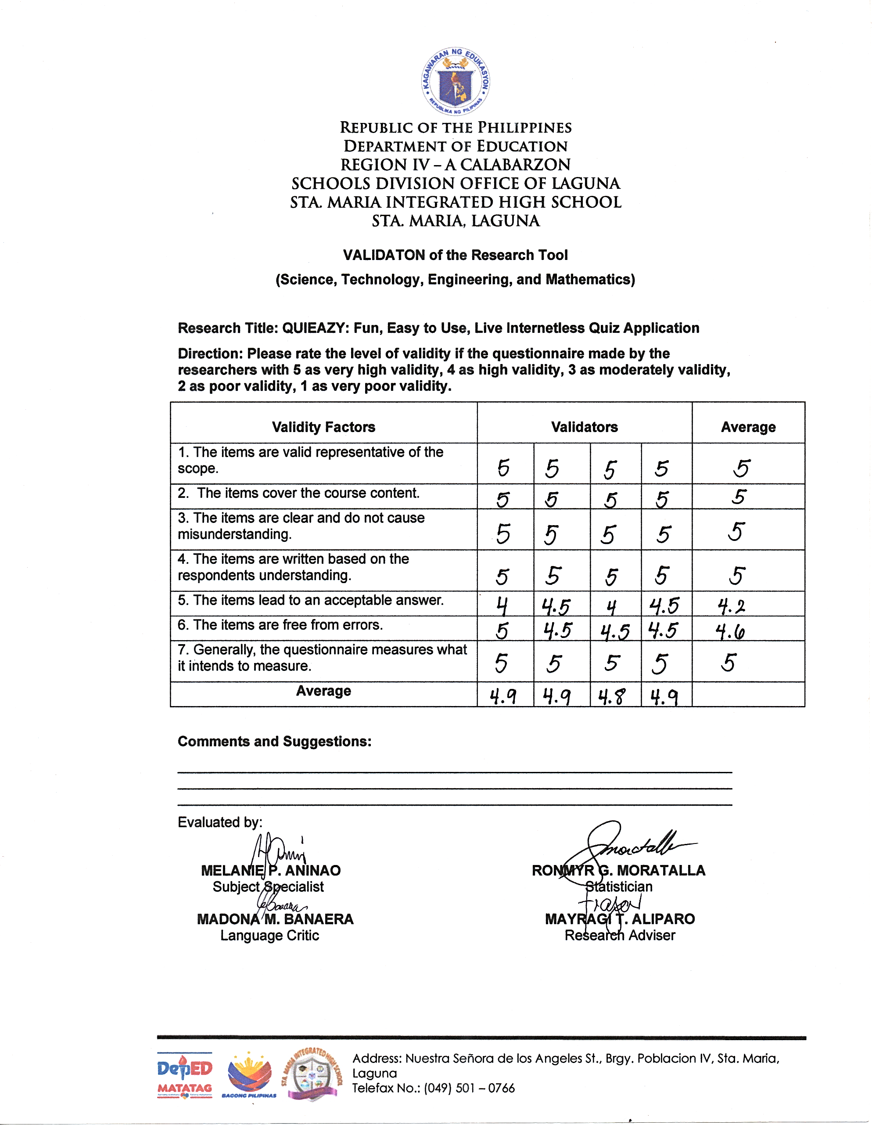
Direction: Please rate the level of validity if the questionnaire made by the researchers with 5 as very high validity, 4 as high validity, 3 as moderately validity, 2 as poor validity, 1 as very poor validity.
Validity Factors | Validators |  |  |  | Average
1. The items are valid representative of the scope.
2. The items cover the course content.
3. The items are clear and do not cause misunderstanding.
4. The items are written based on the respondents understanding.
5. The items lead to an acceptable answer.
6. The items are free from errors.
7. Generally, the questionnaire measures what it intends to measure.
Average

Comments and Suggestions:

___________________________________________________________________________________________________________________________________________________________________________________________________________________________
Evaluated by:

MELANIE P. ANINAO RONMYR G. MORATALLA
Subject Specialist Statistician

MADONA M. BANAERA MAYRAGI T. ALIPARO
Language Critic Research Adviser

VALIDATON of the Research Output
(Science, Technology, Engineering, and Mathematics)

Research Title: QUIEAZY: Fun, Easy to Use, Live Internetless Quiz Application
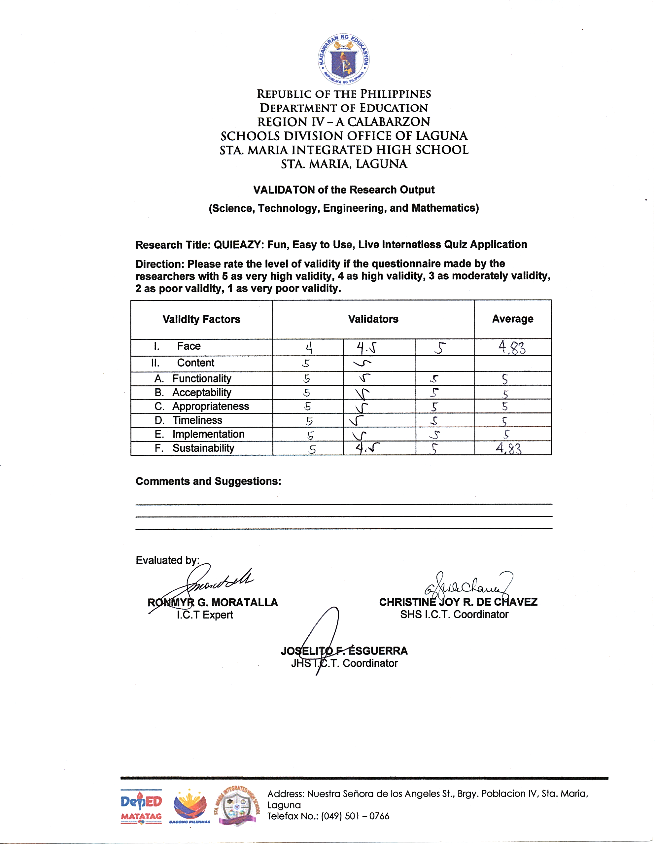
Direction: Please rate the level of validity if the questionnaire made by the researchers with 5 as very high validity, 4 as high validity, 3 as moderately validity, 2 as poor validity, 1 as very poor validity.
Validity Factors | Validators |  |  | Average
I. Face
II. Content
- `Functionality
- Acceptability
- Appropriateness
- Timeliness
- Implementation
- Sustainability

Comments and Suggestions:
___________________________________________________________________________________________________________________________________________________________________________________________________________________________

Evaluated by:

RONMYR G. MORATALLA CHRISTINE JOY R. DE CHAVEZ
I.C.T Expert SHS I.C.T. Coordinator

JOSELITO F. ESGUERRA
JHS I.C.T. Coordinator

